Normal (Bump) Texture

📘 Definition
# Source: AI Source: Provided by: [Data Path: Persons Table -> ID Column: 1, Name_En Column: Motasem Essam] -> From: [ChatGPT] on [5/2/2026]
A Normal (Bump) Texture is a texture used to make a flat 3D surface look like it has small details, bumps, and depth without actually changing its real shape.
It tricks the eye into seeing surface detail that is not really there.

🧱 How normal/bump texture works
# Source: AI Source: Provided by: [Data Path: Persons Table -> ID Column: 1, Name_En Column: Motasem Essam] -> From: [ChatGPT] on [5/2/2026]
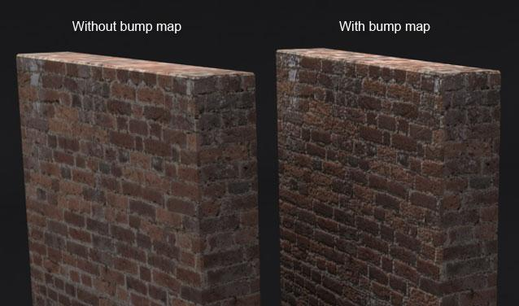
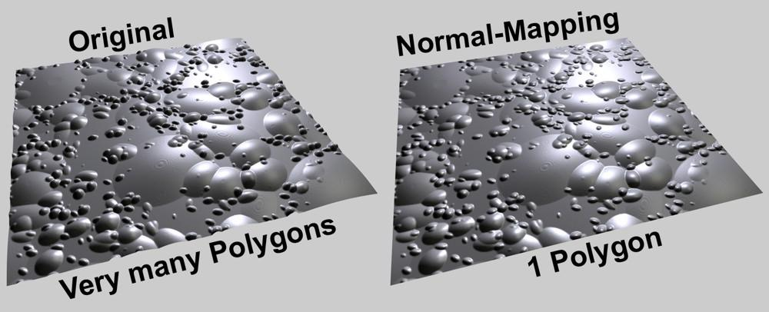
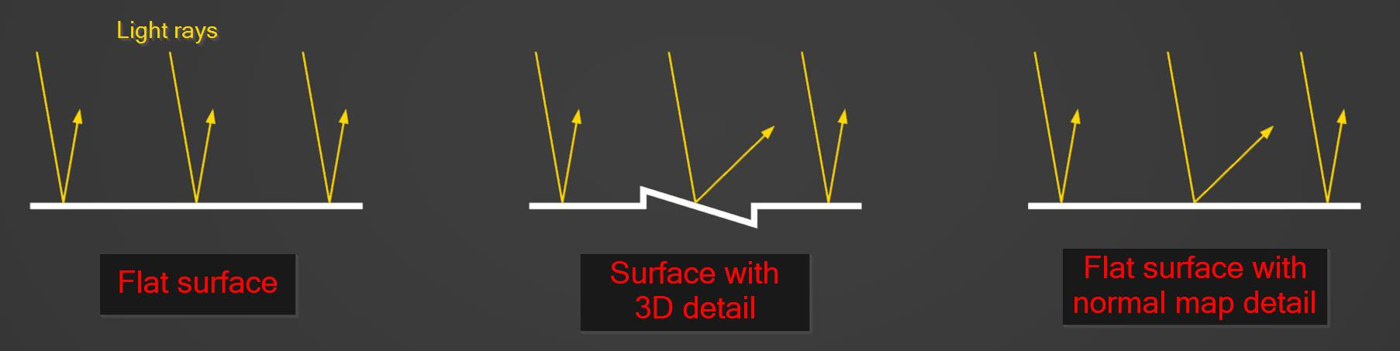
- A special texture (usually purple/blue in normal maps) is applied
- It changes how light interacts with the surface
- The surface appears to have depth and small details
- But the actual geometry does not change

🧠 Simple example
# Source: AI Source: Provided by: [Data Path: Persons Table -> ID Column: 1, Name_En Column: Motasem Essam] -> From: [ChatGPT] on [5/2/2026]
Think of:
- 🧱 A flat wall
- Add a brick normal map → it looks like real bricks with depth
- But if you touch it (or zoom closely), it is still flat

🎮 Where normal/bump textures are used
# Source: AI Source: Provided by: [Data Path: Persons Table -> ID Column: 1, Name_En Column: Motasem Essam] -> From: [ChatGPT] on [5/2/2026]
- 🎮 Video games (rocks, walls, characters)
- 🎬 Movies and CGI (realistic skin, cloth, surfaces)
- 🧑‍🎨 3D modeling and animation
- 🏗️ Architecture visualization

⚙️ Key features
# Source: AI Source: Provided by: [Data Path: Persons Table -> ID Column: 1, Name_En Column: Motasem Essam] -> From: [ChatGPT] on [5/2/2026]
- 🧩 Adds fake surface detail (depth illusion)
- 💡 Affects how light reflects on the surface
- 🚫 Does NOT change actual geometry
- 🎯 Saves performance (no extra polygons needed)

🚀 In short:
# Source: AI Source: Provided by: [Data Path: Persons Table -> ID Column: 1, Name_En Column: Motasem Essam] -> From: [ChatGPT] on [5/2/2026]
Normal/Bump Texture = a special map that makes a flat surface look detailed and bumpy by changing how light reacts to it.

